**Q. A University is setting up a new lab at their premises. Design an algorithm and write Python code to determine the approximate cost to be spent for setting up the lab. Cost for setting the lab is sum of cost of computers, cost of furniture and labor cost. Use the following formulae for solving the problem:**

**Cost of computer = cost of one computer * number of computers**

**Cost of furniture = Number of tables * cost of one table + number of chairs * cost of one chair**

**Labor cost = number of hours worked * wages per hour**

PAC

|  |  |  |  |
| --- | --- | --- | --- |
| **Data** | **Processing** | **Output** | **Solution Alternatives** |
| Cost of one computer,  Number of computers,  Number of tables, Cost of one table,  Number of chairs,  Cost of one chair,  Number of hours worked,  Wages per hour | Cost of computers = Cost of one computer * Number of computers  Cost of furniture = (Number of tables * Cost of one table) + (Number of chairs * Cost of one chair)  Labour cost = Number of hours worked * Wages per hour  Total Cost = Cost of computers + Cost of furniture + Labour Cost | Print Total Cost |  |

Algorithm

* Start
* Use variable **Cost_of_one_computer**, **Number_of_computers**, **Number_of_tables**, **Cost_of_one_table**, **Number_of_chairs**, **Cost_of_one_chair**, **Number_of_hours_worked**, **Wages_per_hour**, **Cost_of_computers**, **Cost_of_furniture**, **Labour_Cost**, **Total_Cost**
* Read **Cost_of_one_computer**, **Number_of_computers**, **Number_of_tables**, **Cost_of_one_table**, **Number_of_chairs**, **Cost_of_one_chair**, **Number_of_hours_worked**, **Wages_per_hour**
* Calculate **Cost_of_computers** = **Cost_of_one_computer** * **Number_of_computers**
* Calculate **Cost_of_furniture** = (**Number_of_tables** * **Cost_of_one_table**) + (**Number_of_chairs** * **Cost_of_one_chair**)
* Calculate **Labour_Cost** = **Number_of_hours_worked** * **Wages_per_hour**
* Calculate **Total_Cost** = **Cost_of_computers** + **Cost_of_furniture** + **Labour_Cost**
* Print **Total_Cost**
* Stop

Flowchart

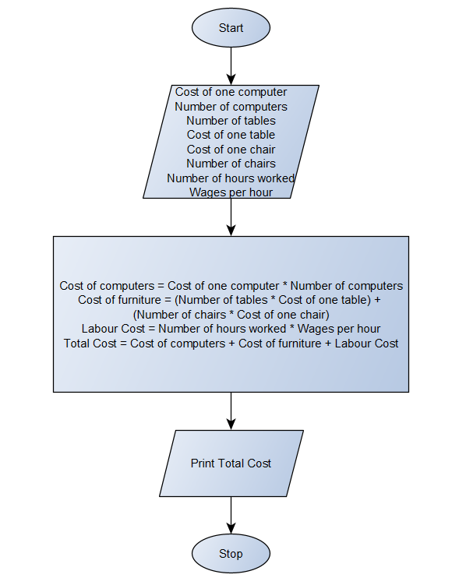

Python Program

Cost_of_one_computer = float(input(**"Enter the cost of one computer : Rs."**))  
Number_of_computers = int(input(**"Enter the number of computers : "**))  
Cost_of_one_table = float(input(**"Enter the cost of one table : Rs."**))  
Number_of_tables = int(input(**"Enter the number of tables : "**))  
Cost_of_one_chair = float(input(**"Enter the cost of one chair : Rs."**))  
Number_of_chairs = int(input(**"Enter the number of chairs : "**))  
Number_of_hours_worked = float(input(**"Enter the number of hours labours worked : "**))  
Wages_per_hour = float(input(**"Enter the wages for labours per hour : Rs."**))  
Cost_of_computers = Cost_of_one_computer * Number_of_computers  
Cost_of_furniture = (Cost_of_one_table * Number_of_tables) + (Cost_of_one_chair * Number_of_chairs)  
Labour_Cost = Number_of_hours_worked * Wages_per_hour  
Total_Cost = Cost_of_computers + Cost_of_furniture + Labour_Cost  
print(**"Bill :"**)  
print(**"Total cost of Computers : Rs."**, Cost_of_computers)  
print(**"Total cost of Furniture : Rs."**, Cost_of_furniture)  
print(**"Total Labour charges : Rs."**, Labour_Cost)  
print(**"Total cost : Rs."**, Total_Cost)